ASP.NET MVC View Engines

Executive Summary
ASP.NET MVC’s extensible architecture provides the ability to leverage more powerful and expressive alternative web markup syntaxes than the traditional Web Forms syntax. There are several engines available, both from Microsoft and the Open Source community, all quite viable alternatives. Due to its familiarity, simplicity, expressiveness, and the fact that it was written as one of the default View Engines for MVC 3+, the new Razor View Engine is a great selection for most new ASP.NET MVC sites.

What is a View Engine?
In the Model-View-Controller (MVC) pattern, the View renders the Model into a form suitable for interaction, typically a user interface. In the case of ASP.NET MVC, this is most often a web page in the form of HTML, CSS, JavaScript, etc. Following the introductory ASP.NET MVC tutorials, most web developers feel right at home because they continue to write their views using the familiar Web Forms syntax. However - keeping in step with the excellent extensibility model throughout the rest of the framework - ASP.NET MVC allows you to replace this default experience with any syntax with the introduction of View Engines.
When we refer to a view engine in ASP.NET MVC, we are talking about three pieces of functionality:
- A template locator/provider (implementation of IViewEngine)
- A template that can render itself (implementation of IView)
- A template engine that can parse and compile the view file syntax into executable code
Combining these three pieces, a view engine provides your controllers with the ability to translate views into HTML.

Why Use an Alternate View Engine?
Though the view engine that ships with ASP.NET MVC has all the functionality you need to create views for just about any website project, it is also easily replaced.
As with choosing a programming language in .NET, there are many reasons why you may choose one view engine over another:
Syntax
ASP.NET MVC’s default view syntax is sometimes described as “tag soup.” This is due to the mix of all the <% … %> tags along with the Html markup and causes some developers to feel like the view is messy.
Productivity
For you, productivity may mean quick and easy to learn syntax or it may mean terse and less code. Depending on which is right for you, you may choose a different view engine.
Specialized Problem Domains
Some view engines use a DSL-like-language to represent the view, which may fit well within your environment.
Testability
View engines that don’t depend on the System.Web.UI.Page are easier to test because it is very difficult and expensive to create an HttpContext outside of the ASP.NET pipeline.
Division of labor
With a view syntax that supports proper separation of front-end logic and markup from backend code, multiple developers and/or designers can work on the same section of an application with minimal conflicts.

Feature Comparisons
View Engine Features
 | Web Forms |  |  |  |  | Razor | Spark |  | NHaml
Multi Line Code Blocks | X |  |  |  |  | X | X |  | X
Inline Expression | X |  |  |  |  | X | X |  | X
Local Functions | X |  |  |  |  |  | X
Local Variables | X |  |  |  |  | X | X |  | X
Global variables |  |  |  |  |  |  | X |  | X
Conditional Output | X |  |  |  |  | X | X |  | X
Support for Multiple Level Conditions | X |  |  |  |  | X | X |  | X
Loops | X |  |  |  |  | X | X |  | X
Html Encoding Shortcuts | X  (ASP.NET 4.0) |  |  |  |  |  | X |  | X
Global Setting for Html Encoding |  |  |  |  |  | X  Limited Escape to prevent Html Encoding | X |  | X
View Language Convenience Features
 |  |  | Web Forms | Razor |  |  |  | Spark |  | NHaml
Global Namespace Imports |  |  | X | X |  |  |  | X |  | X
Import Namespaces |  |  | X | X |  |  |  | X
Master Page Features
 |  | Web Forms |  |  | Razor |  |  | Spark |  | NHaml
Single View Master Page |  | X |  |  | X |  |  | X
Global Master Page |  |  |  |  | X |  |  | X |  | X
Content Placeholders |  | X |  |  | X |  |  | X
Special Partial View Syntax |  |  |  |  |  |  |  | X |  | X
Other Features
 |  | Web Forms |  |  | Razor |  |  | Spark |  | NHaml
Support for Editor Templates |  | X |  |  | X |  |  | X
Visual Studio Integration |  | X |  |  | X |  |  | X |  | X
Supports MonoRail |  |  |  |  | X |  |  | X |  | X

View Language Features
Multi Line Code Blocks Allows you to write multiple lines of code in your views. A related feature is local variables.
Inline Expression An Inline Expression allows you to put a code expression inside static content in the view.
Local Functions Local Functions provide the ability to create functions that can be called in multiple view locations. A related feature is Multi Line Code Blocks.
Local Variables Provide a variable that is scoped to the view.
Global Variables Allows you to provide variables available to all views in your site.
Conditional Output Allows you to use if/else statements to control the output.
Multi-Level Conditionals Provides the ability to nest if/then statements. Conditional output is a related feature.
Loops Allows you to use loop structures to provide repetitive data output.
Html Encoding Shortcuts Provides shortcuts to ensuring returned output is HtmlEncoded.
Global Html Encoding Provides the ability to automatically HtmlEncode returned content.

View Language Convenience Features
Import Namespaces Allows you to import a namespace for a given view so you don’t need to type the fully qualified name of your objects..
Global Namespace Imports Ability to set a namespace import for all views in one location.

Master Page Features
Single View Master Page Provides the ability to set a master page for a single view.
Global Master Page Ability to have a master page that is used for all views by default.
Content Placeholders This feature has two parts. One part allows you to put placeholders in your master page. The second part allows you to specify the content to put in those placeholders. This means a view can optionally populate multiple content placeholders in the master page.
Special Partial View Syntax Provides view language syntax to indicate where a partial view should be output. This is an alternative to the MVC’s framework Html helper extension (Html.RenderPartial).

Other Features
Editor Templates Editor Templates are an MVC 2 feature and allow you to declare what editor template you want loaded on your model classes. Editor Templates are a feature of the ASP.NET MVC framework and are not a feature of the view engine. Not all view engines, however, are able to parse the syntax used to make this work.
Visual Studio Integration Visual Studio integration includes tooling for creating views, as well as IntelliSense and keyword coloring—things we take for granted most of the time.

Web Forms View Engine
Website | http://www.asp.net/mvc
Download site | http://www.asp.net/downloads
License | Microsoft Public License (MS-PL)
Last Release | MVC 2.0 (Last Release), MVC 3.0 (to be released EOY10)
Creator(s) | ASP.NET MVC Team at Microsoft
Support Forum | http://forums.asp.net/1146.aspx
Languages Supported | C#, Visual Basic
ASP.NET MVC Versions | 1.0, 2.0, 3.0

The Web Forms View Engine is one of the two default View Engines provided by Microsoft in ASP.NET MVC 3. ASP.NET developers will find this Engine intimately familiar as it is the syntax that ASP.NET web pages have been written in since the introduction of the .NET Platform. However, the Web Forms View Engine is not the same as the Web Forms platform that developers are used to.
The biggest boon for the Web Forms View Engine is also its biggest drawback: the “intimate familiarity” can produce a false sense of security or empowerment, encouraging developers to revert back to behavior and techniques that either break the MVC pattern or – worst yet – are not supported in the Web Forms View Engine at all, leaving these developers scratching their heads while tracing through their code with a debugger. Assuming proper training and experience can compensate for this learning deficit, the Web Forms View Engine suffers from another detriment: executing the full Web Forms page lifecycle means that the Engine will create objects in memory for all of the server-side controls defined on a page and those objects will go unused. Though the relatively small cost of this behavior is accepted as the cost of doing business in the Web Forms world, it is an unnecessary and avoidable load on the server in an ASP.NET MVC website.
The file extensions used are also borrowed from ASP.NET: .aspx for views, .ascx for partial views (and editor templates), and .master for master pages.
The following is a screen shot of a view written with the default ASP.NET MVC view engine:
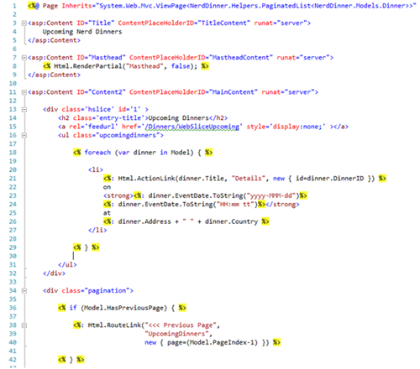
Screenshot 1. NerdDinners Dinner/Index Views using default view engine

History
Though the Web Forms syntax dates to the beginning of the .NET Framework itself, the Web Forms View Engine’s history starts with ASP.NET MVC, which hit CTP in December 2007. This view engine extends ASP.NET’s Page object to provide the view abstraction to MVC. This allows views to be written in the same web forms syntax used in ASP.NET web pages.
The base classes used by the Web Forms View Engine—ViewPage, ViewMasterPage, and ViewUserControl—are derived from the ASP.NET relatives Page, MasterPage, and UserControl, respectively, thus providing a mature rendering capability to the view.

Key Features
The Web Forms supports fourteen desired features.
Feature | Notes
Multi Line Code Blocks
Inline Expression
Local Functions
Local Variables
Conditional Output
Support for Multiple Level Conditionals
Loops
Html Encoding Shortcut | Only when using ASP.NET 4.0
Global Namespace Import | Add in the web.config
Import Namespace
Single View Master Page | 2 Options: Page Directive or Change in the Controller
Content Placeholders
Support for Editor Templates
Visual Studio Integration | Best support of all view engines

Getting Started
The Web Forms View Engine is installed by default with installations of the ASP.NET MVC framework

Dependencies
The Web Forms View Engine is included in the System.Web.Mvc.dll, so the view engine is versioned with the ASP.NET MVC framework you reference. However, some of the features of the Web Forms View Engine are dependent on the version of the .NET framework/ASP.NET you are using. For example, if you are using .NET 3.5, to Html encode an output value you need to use syntax like the following:
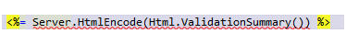
Figure 1. ASP.NET Html Encode
If you are using .NET 4.0, you can use the new “Code Nugget” syntax to do the same thing:
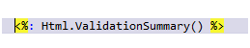
Figure 2. ASP.NET 4.0 Html Encoding Syntax

Feature Syntax Examples
Since syntax is one of the main reasons you may want to use an alternative view engine, I have included some examples of the corresponding key features. This is not meant to be a language reference; rather, it is included to help you get a feel for how you may implement a view using the different view engines:

Multi-Line Code Block
<%
string message = "The time is: {0}";
string timeString = DateTime.Now.ToShortTimeString();
string output = string.Format(message, timeString);
%>

Inline Expression
<img src="<%=Url.Content("~/content/images/alert.jpg")%>" />

Local Function
<script runat="server">
string FunctionCallOnServerSide()
{
return "Hello World!";
}
</script>

<div>
Server Says: <%=FunctionCallOnServerSide() %>
</div>

Local Variable
<%
string message = "Hello World";
%>
The result message is: <%= message %>

Conditional Output
<strong>Who's Coming:</strong>

<% if (Model.RSVPs.Count == 0){%>

<span>No one has registered.</span>

<% } %>

Multi Level Condition Output
<% if (Request.IsAuthenticated) { %>

<% if (Model.IsHostedBy(Context.User.Identity.Name)) { %>

<p>You are the host for this event!</p>

<% } else { (Model.IsUserRegistered(Context.User.Identity.Name)) { %>
<p>You are registered for this event!</p>
<% } %>

<% } else { %>
<strong>RSVP for this event:</strong>
<% } %>

For Loop
<% foreach (var dinner in Model) { %>
<li>
<%: Html.ActionLink(dinner.Title, "Details", new { id=dinner.DinnerID }) %>
</li>
<% } %>

Html Encoding Shortcut
<%: dinner.Address + " " + dinner.Country %>

Global Namespace Import in Web.Config
<pages controlRenderingCompatibilityVersion="3.5" clientIDMode="AutoID">
<namespaces>
<add namespace="System.Web.Mvc" />
<add namespace="System.Web.Mvc.Ajax" />

Importing a Namespace in a View
<%@ Import Namespace=”NerdDinner.Helpers" %>

Setting Master Page in View’s Page Directive
<%@ Page Language="C#" MasterPageFile="~/Views/Shared/Site.Master" %>

Changing Master Page in Controller:
public ActionResult About() {
var result = View();
result.MasterName = "AlternateMaster";
return result;
}

Master Page with Content Placeholders
<head id="Head1" runat="server">
<title>
<asp:ContentPlaceHolder ID="TitleContent" runat="server" />
</title>
<asp:ContentPlaceHolder ID="HeadContent" runat="server" />
</head>

View with Multiple Content Elements
<asp:Content
ID="TitleArea"
ContentPlaceHolderID="TitleContent"
runat="server">
About
</asp:Content>
<asp:Content
ID="HeadArea"
ContentPlaceHolderID="HeadContent"
runat="server">
<script
src="<%=Url.Content("~/Scripts/jquery-1.4.1.min.js")%>"
type="text/javascript"></script>
</asp:Content>

Visual Studio Integration
Being the first view engine available for ASP.NET MVC also means that the Web Forms View Engine has an advantage over other view engines when it comes to Visual Studio tooling and support. Once you install ASP.NET MVC, you have the default view engine integrated into Visual Studio – which provides a lot of tooling for your views.
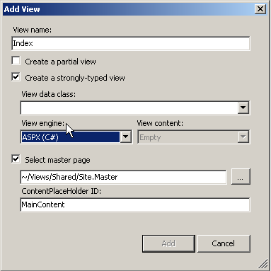
Figure 1. Add View Dialog
The Visual Studio tooling provides an Add View Dialog (shown above) when you create a new view, which provides the following features:
- Ability to specify whether the view is a partial view or normal view
- Choice of the type of view model you want
- Option to choose a T4 template for generating the view content or just create an empty view
- Option to use a master page and set the content placeholder for the view’s content

IntelliSense Support
Visual Studio provides complete IntelliSense support for views using the Web Forms View Engine, including support for the directives used at the top of the page (page settings, namespace imports, etc.) and usage documentation as you type, as well as all other .aspx and .ascx productivity enhancements added by Visual Studio over the years, including ASP.NET MVC, HTML markup, and JavaScript Snippets (new in VS 2010).
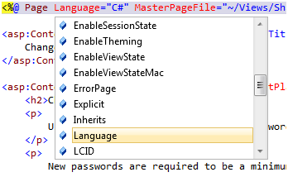
Figure 2. Page Directive IntelliSense
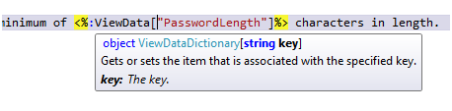
Figure 3. Usage Documentation IntelliSense
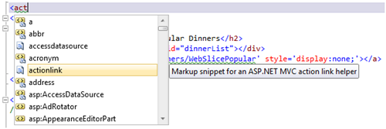
Figure 4. ASP.NET MVC Snippet for Action Link Start
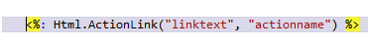
Figure 5. ASP.NET MVC Snippet for Action Link Result

Getting Support
The Web Forms View Engine is part of the ASP.NET MVC framework and is supported the same way as the framework. The primary support forum for the ASP.NET MVC framework can be found at: http://forums.asp.net/1146.aspx

Strengths
- Web Form developers can utilize their web form development experience
- It is included with ASP.NET MVC
- It is supported along with the ASP.NET MVC framework

Weaknesses
- Web Forms was not made for the MVC pattern and as such, many Web Forms developers may be tempted to use techniques that either break the MVC pattern or do not work under MVC at all
- The syntax can lead to views becoming “tag soup”
- Hard to test due to a dependency on Page

Razor
Website | http://www.asp.net/mvc
License
Last Release | Pre-releases: WebMatrix Beta and MVC 3 Beta (Release date: EOY10)
Creator(s) | ASP.NET MVC Team at Microsoft
Support Forum | http://forums.asp.net/1146.aspx
Languages Supported | C#, Visual Basic
ASP.NET MVC Version | 3.0

The Razor View Engine is a new View Engine created specifically for the needs of the ASP.NET MVC framework and is one of the two default View Engines provided by Microsoft in ASP.NET MVC 3. This View Engine does away with the Web Forms paradigm and instead focuses on the needs of MVC Views – not on data binding to server controls, but on generating HTML from Models. Because it is one of the default view engines provided (and supported) by Microsoft - and it was created specifically for the needs of ASP.NET MVC views – Razor should be the default view engine of choice for anything but the most mundane ASP.NET MVC sites. Though currently in the Beta stage at the time of this writing, I have confirmed with the ASP.NET MVC team that MVC 3 (including the Razor engine) should be released by the end of 2010.
The Razor view engine is being designed to mix the code and markup together—not in the same sense as Spark (there aren’t any elements to represent functionality), but in the sense that the code and markup play well together with minimal control characters. Unlike the Web Forms View Engine, Razor does not extend the System.Web.Page class.
The file extension currently used for views, partial views and layouts (master pages) is .cshtml and also in the future .vbhtml for VisualBasic support.
Below is a screenshot of a view written using the Razor view engine.
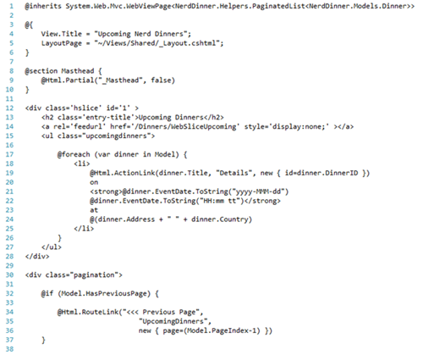
Screenshot 4. NerdDinners Dinner/Index View in Razor

History
Created for the needs of the ASP.NET MVC as well as the Web Matrix project

Key Features
Razor currently supports 14 features (plus more coming soon) from the desired feature list.
Feature | Notes
Multi Line Code Blocks
Inline Expression
Local Functions
Local Variables
Conditional Output
Support for Multiple Level Conditionals
Loops
Global Setting for Html Encoding | No setting currently , it is just on by default
Import Namespaces
Global Namespace Imports
Single View Master Page
Global Master Page
Content Placeholders
Support for Editor Templates
Visual Studio Integration | IntelliSense coming in final release

Getting Started
The Razor view engine is installed by default with ASP.NET MVC 3

Dependencies
The Razor view engine is in the System.Web.Mvc.dll and shipped with the MVC 3 framework, so there are no external dependencies.

Feature Syntax Examples

Multi Line Code Blocks
@{
string message = "The time is: {0}";
string timeString = DateTime.Now.ToShortTimeString();
string output = string.Format(message, timeString);
}
The result from serverside code is: @output

Inline Expression
<img src="<%=Url.Content("~/content/images/alert.jpg")%>" />

Creating and Using a Local Variable
@{
string message = "Hello World";
}
The result message is: @message

Conditional Output
<strong>Who's Coming:</strong>
@if (Model.RSVPs.Count == 0) {
<text>No one has registered.</text>
}

Multi Level Condition Output
@if (Request.IsAuthenticated) {
if (Model.IsHostedBy(Context.User.Identity.Name)) {
<p>You are the host for this event!</p>
} else if (Model.IsUserRegistered(Context.User.Identity.Name)) {
<p>You are registered for this event!</p>
}
}
else
{
<strong>RSVP for this event:</strong>
}

Loop - Foreach
@foreach (var dinner in Model) {
<li>
@Html.ActionLink(dinner.Title, "Details", new { id=dinner.DinnerID })
</li>
}

Global Namespace Import (Same as WebFormsViewEngine)
<pages>
<namespaces>
<add namespace="System.Web.Mvc" />
<add namespace="System.Web.Mvc.Ajax" />

Importing a Namespace in a View
@using NerdDinner.Helpers;

Global Master Page Support
Razor has the concept of a site wide master page (or layout) like Spark and NHaml. This allows you to create a master page in the Views/Shared directory named Application.spark and you don’t have to specify the layout page in the individual views.

Setting a Master Page (Layout) in a View
@{ LayoutPage = "~/Views/Shared/_Layout.cshtml"; }

Master Page with Content Placeholders
<head>
<title>@View.Title</title>
@RenderSection("HeadArea", optional:true)
</head>

View with Multiple Content Elements
@{
View.Title = "Upcoming Nerd Dinners";
LayoutPage = "~/Views/Shared/_Layout.cshtml";
}

@section HeadArea {
@Html.Partial("_Head", false)
}

This text will be in the view's main content … notice this is not in a section.

Visual Studio Integration

New Project Template for Razor
There are now two choices for ASP.NET MVC 3 Web Applications – one for the ASPX (WebFormsViewEngine) and the other for Razor.
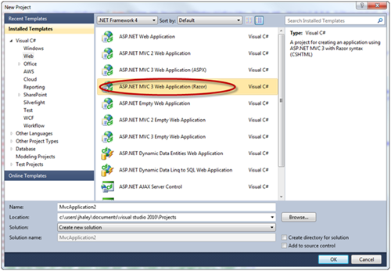

Add View Dialog
The add View Dialog box, now allows you to choose which view engine you are using – and Razor is now a choice for you.
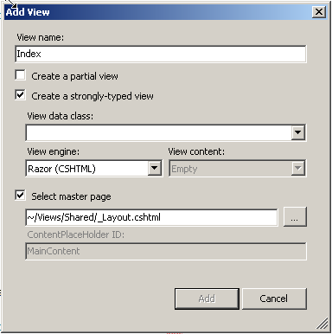

Getting Support
The MVC 3.0 release will be fully supported by Microsoft. You can get additional community (and often team) support in the forums at: http://forums.asp.net/1146.aspx

Strengths
- Easy to learn
- Views are cleaner than Web Forms View Engine syntax
- Views don’t use the Page class so they are easier to test

Weaknesses
- Currently (Oct. ’10) in Beta, to be released by the end of year 2010
- Current documentation is minimal with no central location to find information on the view engine.
- Error messages are hard to decipher when you get the syntax wrong

Spark View Engine
Website | http://sparkviewengine.com/
Download site | http://sparkviewengine.codeplex.com/
License | Apache License, Version 2.0
Last Release | Spark v1.1 (March 11, 2010)
Creator(s) | Louis DeJardin
Support Forum | http://groups.google.com/group/spark-dev?pli=1
Languages Supported | C#, Visual Basic, Iron Python, Iron Ruby
ASP.NET MVC Versions | 1.0, 2.0, 3.0

The Spark view engine was designed to mix the code into the flow of the html, which leads to nicer looking views without all the escape syntax that dominates the Web Forms View Engine’s syntax.
Spark has been around for more than two years now and has a lot of features you won’t find in the default view engine. Unlike the Web Forms View Engine, Spark has its own view class and doesn’t extend the ASP.NET Page class. Spark also works with both ASP.NET MVC and Castle MonoRail MVC Framework.
The Spark view engine differs from the other view engines because it mixes its language syntax in with the elements of your view. The language constructs exist mostly as elements and attributes. For example, there is an <if> element and a <for> element, and partial views can also be represented as an element. This approach takes some getting used to for those who are accustomed to the Web Forms syntax.
The file extension used for views, partial views, and layouts (master pages) is .spark
Below is a screen shot of a view written using the Spark view engine:
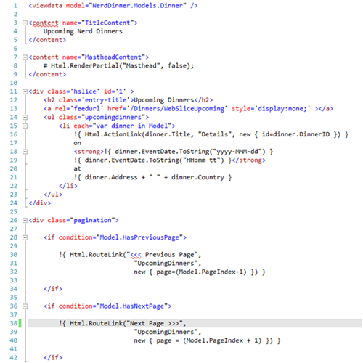
Screenshot 2. NerdDinners Dinner/Index View in Spark

History
Louis DeJardin began developing the Spark view engine in May 2008, soon after reading a blog entry by Phil Haack (Code Based Repeater for ASP.NET MVC). Louis designed and wrote the view engine from ground up (it is not a port of another view engine or language) in order to build a view syntax able to seamlessly mix the code into the Html.

Key Features
Spark is the only view engine of the four that supports all of the features on my desired feature list.
Feature | Notes
Multi Line Code Blocks
Inline Expression
Local Functions | Called ‘Macros’, limited to functions that return strings  Also supports global functions.
Local Variables
Global Variables
Conditional Output
Support for Multiple Level Conditionals
Loops
Html Encoding Shortcut
Global Setting for Html Encoding
Import Namespaces
Global Namespace Imports | Add in the web.config or _global.spark file
Single View Master Page
Global Master Page
Content Placeholders
Special Syntax for Partial Views | If partial view file begins with ‘_’ can use the name as an element in the view.
Support for Editor Templates
Visual Studio Integration | Add-ins exist for VS 2008 and VS 2010
Support for Other MVC Frameworks

Getting Started
Spark is available for download at http://sparkviewengine.codeplex.com/. After you have downloaded and extracted the binaries, add Spark as a view engine in your ASP.NET MVC project by performing the following steps:
1. Set a reference to the Spark.dll and Spark.Web.Mvc.dll libraries included in the release download.
2. Open the Global.asax.cs file and add a new SparkViewFactory to the ViewEngines.Engines collection:
void Application_Start()
{
RegisterRoutes(RouteTable.Routes);

ViewEngines.Engines.Add(new SparkViewFactory());
}
3. In your web.config file, add a section to your configSections for the SparkSectionHandler as shown below:
<configuration>
<configSections>
<section name="spark" type="Spark.Configuration.SparkSectionHandler, Spark"/>
4. Add the <spark> section to your web.config file. I put mine just after the </connectionStrings> element. Below is the configuration section I used to port the NerdDinner project to Spark.
<spark>
<compilation debug="true" defaultLanguage="CSharp" />
<pages automaticEncoding="true" >
<namespaces>
<add namespace="System"/>
<add namespace="System.Collections.Generic"/>
<add namespace="System.Linq"/>
<add namespace="System.Web"/>
<add namespace="System.Web.Mvc"/>
<add namespace="System.Web.Mvc.Html"/>
</namespaces>
</pages>
</spark>
5. Change the settings as necessary (check the documentation for the options that apply to you).

Dependencies
For Spark to work as a view engine in your ASP.NET MVC project, you need references to the Spark.dll and Spark.Web.Mvc.dll

Feature Syntax Examples
The following are examples for the key features listed above:

the # Statement for Escaping Multiple Lines of Code
# string message = "The time is: {0}";
# string timeString = DateTime.Now.ToShortTimeString();
# string output = string.Format(message, timeString);
The result from serverside code is: ${output}

${ } for an Inline Expression
<img src="${ Url.Content("~/content/images/alert.jpg") }" />
One drawback to using the ${} syntax is that it will fail if the expression returns null. In order to protect against the possibility of an expression returning null, you can use the $!{} expression.

!${} to Output an Expression that May Return Null
<span class="fn nickname">$!{ Model.RSVPs.FirstOrNull() }</span>

Local Function (Macro) in Spark:
<macro name="FunctionCallOnServerSide" message="string">
<b>${message}</b>
</macro>

<div>
This is client side html
Server Says: ${ FunctionCallOnServerSide("OutputMessage") }
and more client side html
</div>

Creating and Using a Local Variable
<var RSVPs = "Model.RSVPs.Reverse()"/>
${RSVPs.Count().ToString() }

Creating and Using a Global Variable
<global version="0.01F" type="float" />
${version + 1}

Conditional Output - If/Else Element
<strong>Who's Coming:</strong>
<if condition="Model.RSVPs.Count == 0">
<span>No one has registered.</span>
</if>
<else>
... other markup here ...
</else>

Conditional Output - if Attribute
<strong>Who's Coming:</strong>
<span if="Model.RSVPs.Count == 0">No one has registered.</span>
<else>
... other markup here ...
</else>

Multi Level Condition Output
<if condition="Request.IsAuthenticated">
<if condition="Model.IsHostedBy(Context.User.Identity.Name)">
<p>You are the host for this event!</p>
</if>
<else if="Model.IsUserRegistered(Context.User.Identity.Name)">
<p>You are registered for this event!</p>
</else>
<else>
<strong>RSVP for this event:</strong>
</else>

Loop - For Element
<ul class="upcomingdinners">
<for each="var dinner in Model">
<li>
!{ Html.ActionLink(dinner.Title, "Details", new { id=dinner.DinnerID }) }
</li>
</for>
</ul>

Loop - each Attribute
<ul class="upcomingdinners">
<li each="var dinner in Model">
!{ Html.ActionLink(dinner.Title, "Details", new { id=dinner.DinnerID }) }
</li>
</ul>

Global Html Encoding Setting
For html cncoding you can set the automaticEncoding flag in the spark section of your web.config file to turn html encoding on by default. This will cause every ${expr} expression evaluation to be Html encoded.
If you need to specify an expression to not be Html encoded, use the !{ expr } syntax.
<spark>
<compilation debug="true" defaultLanguage="CSharp" />
<pages automaticEncoding="false" >

Html Encoding Inline
Spark provides a utility method that will Html Encode expressions called H( ). However, I recommend having automaticEncoding on via the global setting and using the !{ } syntax for when you don’t want to include Html Encoding.

Global Namespace Import in Web.Config
<spark>
<compilation debug="true" defaultLanguage="CSharp" />
<pages automaticEncoding="false" >
<namespaces>
<add namespace="System"/>
<add namespace="System.Collections.Generic"/>

Importing a Namespace
<use namespace="NerdDinner.Helpers" />

Global Master Page Support
Spark includes a site-wide master page (or layout), which allows you to have all views use a master page without having to specify the name for each of the views.
In order to create a global master page/layout, create an Application.spark file in the Views/Layouts folder or the Views/Shared folder.
You can also create a layout for a specific controller. To do so, create a layout with the same name as the controller.

Setting Master Page in a View
<use master="AlternateMaster" />

Master Layout with Multiple Content Elements
<head>
<title><use content="TitleContent" /></title>
<use content="HeadContent" />
</head>

View with Multiple Content Elements
<content name="TitleContent">
Upcoming Nerd Dinners
</content>

<content name="HeadContent">
# Html.RenderPartial("Masthead", false);
</content>
This text will be in the view's main content … notice this is not in a content element.

Special Partial View Syntax
Spark provides a special partial view syntax that,flows better than the HtmlHelper syntax. If the name of your partial view file begins with an underscore character, you can use an element in your content to represent the partial view (minus the underscore). For example, in my NerdDinner Spark port, there is a layout named _LoginStatus.spark. This allows me to use the element <LoginStatus /> to represent the output location I want for the contents of that partial view.

Visual Studio Integration
Since Spark is a third party view engine, the Visual Studio tooling isn’t as good as the Microsoft view engines. This means that you currently don’t get the functionality provided by the Add View dialog described in the Web Forms View Engine section and so are stuck working with text or html looking files.

IntelliSense Support
For Visual Studio 2008, there is an msi installer included for the 3-9-2009 Build available on the http://sparkviewengine.com/download site.
For Visual Studio 2010, there is a Visual Studio Addin available in Visual Studio Gallery: SparkSense.

Getting Support
For an open source project, Spark is pretty well documented. The documentation can be found on the project site at http://sparkviewengine.com/documentation.
The Spark View Engine also has a Google Group where you can get answers to your questions: http://groups.google.com/group/spark-dev.
The Issue Tracker is available on the on the CodePlex site: http://sparkviewengine.codeplex.com/workitem/list/basic.

Strengths
- Syntax produces clean views
- Views don’t use the Page class and so are easier to test
- Well documented with a lot of samples included in the download
- Supports other MVC frameworks

Weaknesses
- Visual Studio tooling isn’t as good as the default view engine
- Advanced usage of some features can make the views harder for a developer to follow

NHaml View Engine
Website | http://code.google.com/p/nhaml/
Download site | http://code.google.com/p/nhaml/downloads/list
License | MIT License
Last Release | Nhaml-2.0-beta-4 (August, 20, 2010)
Creator(s) | Andrew Peters
Support Forum | http://groups.google.com/group/nhaml-users
Languages Supported | C#, Visual Basic, Iron Ruby, Boo, F#
ASP.NET MVC Versions | 1.0, 2.0

The NHaml (pronounced enamel) view engine is an implementation of the Rails Haml view engine, and its syntax is an abstraction of usual tag based XHTML syntax used by most view engines. As you can see in the screen shot below, it takes only 19 lines in NHaml to create the same view created with 42 lines in the Web Forms View Engine and Spark view engines. A couple of other differences are that the syntax is white space sensitive and you don’t have to set the type of the view model (it figures it out for you).
The file extension used for views, partial views and layouts (master pages) is .haml
Below is a screen shot of a view written using the NHaml view engine:
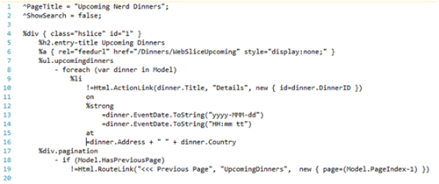
Screenshot 3. NerdDinners Dinner/Index View in NHaml

History
Haml was started in May 2006 by Hampton Catlin and it seems Andrew Peters introduced NHaml to the world in December 2007. The syntax is pretty much the same as Haml, but the parsing/compiling was all written from the ground up. Like Spark, NHaml does not derive from ASP.NET’s Page base class.

Key Features
NHaml supports 14 features from the desired feature list.

Feature | Notes
Multi Line Code Blocks
Inline Expression
Local Variables
Global Variables
Conditional Output
Support for Multiple Level Conditionals
Loops
Html Encoding Shortcut
Global Setting for Html Encoding
Global Namespace Imports | Have to add all namespace imports to the web.config
Global Master Page
Special Syntax for Partial Views
Visual Studio Integration | Add-in exist for VS 2008
Support for Other MVC Frameworks

Getting Started
NHaml is available for download from the project’s website athttp://code.google.com/p/nhaml/downloads/list. After you have downloaded the release package and extracted its contents, you can add the NHaml view engine to your ASP.NET MVC project by performing the following steps:
1. Set a reference to the NHaml.dll and NHaml.Web.Mvc.dll libraries included in the release download.
2. Open the Global.asax.cs file and add a new NHaml.Web.NHamlMvcViewEngine to the ViewEngines.Engines collection:
void Application_Start()
{
RegisterRoutes(RouteTable.Routes);

ViewEngines.Engines.Add(new NHaml.Web.Mvc.NHamlMvcViewEngine());
}
3. In your web.config file, add a section to your configSections for the NHamlConfigurationSection handler as shown below:
<configuration>
<configSections>
<section name="nhaml"type="NHaml.Configuration.NHamlConfigurationSection, NHaml"/>
4. Add the <nhaml> section to your web.config file. As mentioned in the Spark setup, I put mine right after the </connectionStrings> element. Below is the section I used to port the NerdDinner project to NHaml—notice it has more assemblies and namespace declarations than the one provided in the Spark setup:
<nhaml autoRecompile="true" templateCompiler="CSharp4" encodeHtml="true"
useTabs="true" indentSize="4">
<assemblies>
<clear/>
<add assembly="System, Version=2.0.0.0, Culture=neutral, PublicKeyToken=B77A5C561934E089"/>
<add assembly="NerdDinner, Version=1.0.0.0, Culture=neutral, PublicKeyToken=null"/>
<add assembly="DDay.iCal, Version=0.80.0.0, Culture=neutral, PublicKeyToken=1790ba318ebc5d56" />
<add assembly="Elmah, Version=1.0.10617.0, Culture=neutral, PublicKeyToken=null" />
<add assembly="DotNetOpenAuth, Version=3.4.4.10162, Culture=neutral, PublicKeyToken=2780ccd10d57b246" />
<add assembly="OpenSearchToolkit, Version=1.0.0.0, Culture=neutral, PublicKeyToken=null"/>
</assemblies>
<namespaces>
<clear/>
<add namespace="System.Collections"/>
<add namespace="NerdDinner" />
<add namespace="NerdDinner.Helpers" />
<add namespace="NerdDinner.Models" />
<add namespace="DotNetOpenAuth.OpenId.RelyingParty" />
<add namespace="DotNetOpenAuth.Mvc" />
<add namespace="System.Web.Mvc.Html" />
<add namespace="System.Web.Mvc" />
<add namespace="System.Globalization" />
<add namespace="System.Web.Mvc.Ajax" />
<add namespace="System.Linq" />
</namespaces>
</nhaml>
5. Check the configuration documentation at http://code.google.com/p/nhaml/wiki/Configuration to determine your project needs.

Dependencies
In order to be used, the NHaml view engine requires that the following two dll’s be referenced in your MVC project: NHaml.dll and NHaml.Web.Mvc.dll.

Feature Syntax Examples
Whitespace is important and represents the hierarchy of the final XHTML document being marked up in the view in addition to the scoping of things such as for loops and if statements.

Multi-Line Code Block
- string message = "The time is: {0}";
- string timeString = DateTime.Now.ToShortTimeString();
- string output = string.Format(message, timeString);
The result from serverside code is:
=output

Inline Expression
To indicate which code should be evaluated in NHaml, you use either universal interpolation or evaluate output. The Universal Interpolation allows you to leave expressions to be evaluated in the middle of a line even though the evaluate output is typically at the beginning of a line.

The #{ } Syntax to Evaluate Inline Code
%a { class="feed" href=#{Url.Action("iCalFeed", "Services", null, "webcal")} }

The = Syntax to Evaluate and Output Code
=dinner.Address + " " + dinner.Country

Creating and Using a Local Variable
- string message = "The time is a message";
The result from serverside code is:
=message

Creating and Using Global Variable
^ string PageTitle = "";

- if (PageTitle != "")
%title=PageTitle

Conditional Output
%strong Who's Coming:
- if (Model.RSVPs.Count == 0)
No one has registered.

Multi Level Condition Output
- if (HttpContext.Current.Request.IsAuthenticated)
- if (Model.IsHostedBy(HttpContext.Current.User.Identity.Name))
%p You are the host for this event!
- else if (Model.IsUserRegistered(HttpContext.Current.User.Identity.Name))
%p You are registered for this event!
- else
%strong RSVP for this event:

Loop - foreach
- foreach (var dinner in Model)
%li
!=Html.ActionLink(dinner.Title, "Details", new { id=dinner.DinnerID })

Global Html Encoding Setting in Web.Config
<nhaml autoRecompile="true" templateCompiler="CSharp4" encodeHtml="true"useTabs="true"
indentSize="4">

Html Encoding Inline
&= dinner.Address + " " + dinner.Country

Global Master Page Support
NHaml has the concept of a site-wide master page (or layout) named Application.haml. In the layout, the view’s contents have a special placeholder ‘_’.
!!!
%html
%head
_ TitleContent
_ HeadArea
%body
_

Special Partial View Syntax
In NHaml, partial views use a ‘_’ as the first character in their file names. This allows you to place the contents of a partial view in another view (or layout) by using the special syntax of _ <viewname>.
_ LoginStatus

Visual Studio Integration
Like Spark, NHaml is a third party view engine started by one person, so the Visual Studio tooling isn’t as good as the default view engine, though a few addins have been created by the community. Dave Newman created a syntax highlighting add-in for Visual Studio 2008: http://github.com/snappycode/hamleditor
There is also an Intellisense project for NHaml created by sztupy and available at: http://github.com/sztupy/nhamlsense for Visual Studio 2008.

Getting Support
Although NHaml has been around for a little longer than Spark, it isn’t quite as well documented (less reference material and less samples).
A pretty good language reference can be found on the project’s site at: http://code.google.com/p/nhaml/wiki/NHamlLanguageReference
NHaml also has a Google Group where you can get answers to your questions: http://groups.google.com/group/nhaml-users
As with Spark (don’t forget it is Open Source), you can look at the code and attempt to figure out how things work on your own without using any documentation or support.

Strengths
- Terse syntax that creates views with less code
- Has a lot of features that help create html
- Views don’t use the Page Class and so are easier to test
- Supports languages other than C# and Visual Basic

Weaknesses
- The drastically different syntax results in a greater learning curve
- Poorly documented with hard to find samples
- Error messages make it difficult to decipher syntax errors

